**This is a general overview of the current progress for rebuilding the Cherenkov Counters.**

**The process began with the construction of a clean room facility within the TEDF. After the particle count was a respectable 200 particles per cubic foot @0.5 μm, each sector was brought into the clean room one by one and completely disassembled internally.**

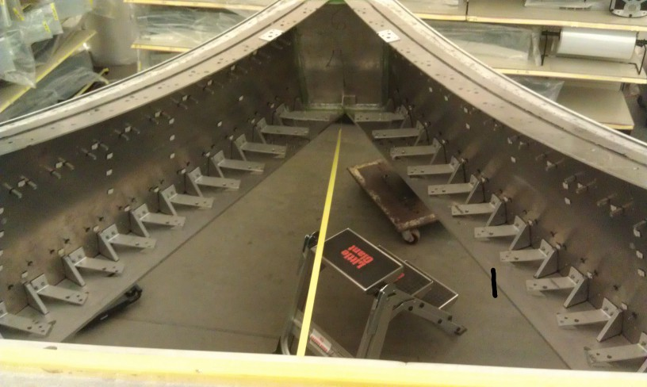

**Here is an example of a Cherenkov Counter that has been totally disassembled internally.**

**All the individual components within the Cherenkov Counters were packaged for later shipping, neatly stacked in baskets or organized on shelves where they will be readily accessible for the later stages of the rebuilding process. For instances, all the Winston cones, PMT’s and small angle mirrors were wrapped in bubble wrapped and boxed to prepare them for shipping where they will be recoated or refurbished as needed.**

**After each Cherenkov Counter Unit was disassembled internally, it was moved outside and placed in front of Physics Storage where the next phase would begin. All the old window material had to removed as well as all of the epoxy used to attach the window to the Cherenkov Counter itself.**

**This was a very messy and labor intensive procedure that had to be performed outside due to the large amount of dust and debris that was created by removing the old materials.**

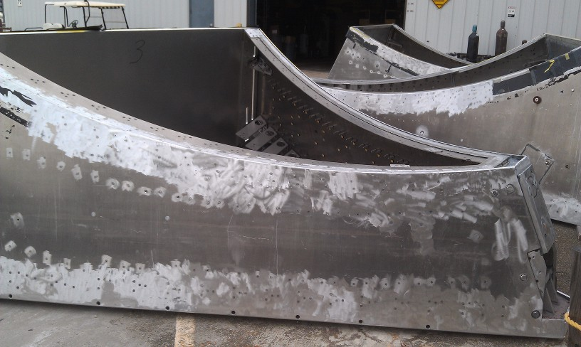

**Cherenkov Counters outside Physics Storage cleaned and ready for the next stage**

**Once the individual units are cleaned of old epoxy and window material they are transported to the ESB where the back wall and patch panels are then removed for replacement and modification. Due to the new engineering plans for the units which require a reduction of the sidewall height, 6 mirror sets, cans, PMT’s and Winston Cones must be shifted down as much as possible to maximize the distance between those 6 top and bottom mirrors for the maximum efficiency that’s possible due to the reduction of the sidewalls at the back corners of the units. The back wall will then be cut down both vertically and horizontally to accommodate the new patch panels and reduced side wall height. After all the sets have been moved the old location holes had to be drilled, tapped and sealed with Loctite Thread Sealant. As an additional precaution to ensure a proper gas seal, DAP RTV Black silicone caulk was applied to the inside surfaces. Any penetrations or seams were sealed with the same procedure and products.**

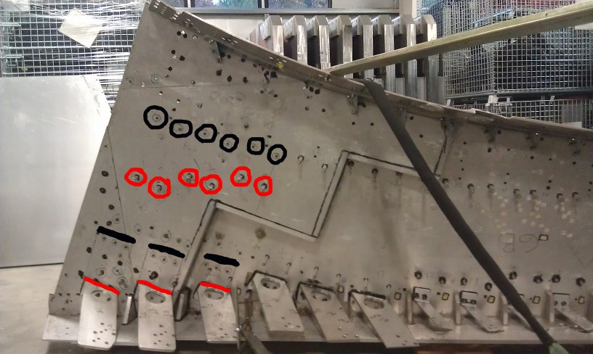

**As depicted above, mirror sets 16, 17 and 18 have been shifted downward. The black circles and lines indicate the original location and the red circles and lines show the new positions.**

**To accommodate the temporary storage of 432 mirrors,**  **A shelving system was purchased and assembled in the TEDF clean room . After some trial and error a system was developed that allowed easy access to all the mirrors at any given time. This will be very important when we begin the process of recoating the mirrors. Vendors are currently still being interviewed to fulfill our needs within our budget restrictions for the Aluminum coated Lexan. It will require approximately 1/5th of a mile of Aluminum coated Lexan to cover all the mirrors.**

**Many hours were dedicated to testing adhesives as a bonding agent for the new mirror coating. There were many factors to consider while choosing the correct method and bonding agent, so all avenues were explored. It was decided a spray adhesive (Loctite® Spray Adhesive High Performance) was the best choice. With this new information we were able to R&D fixtures that would have the ability to hold the mirrors and the new coating in the proper orientation firmly.**

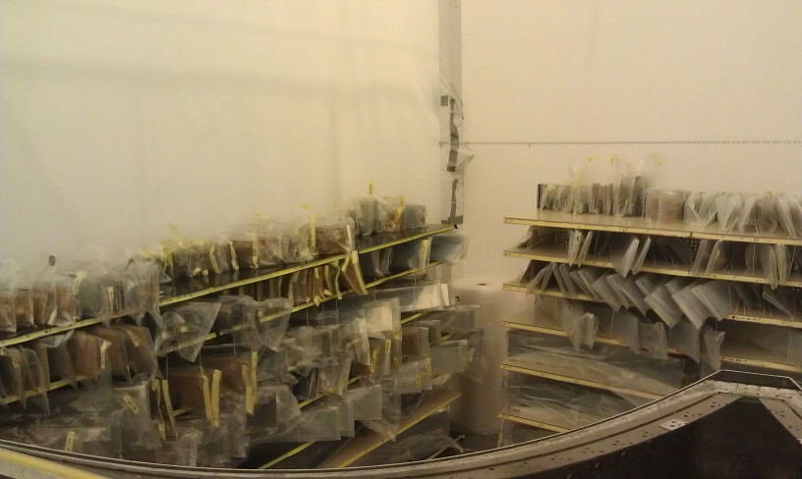

**432 mirrors organized on the clean room shelves**

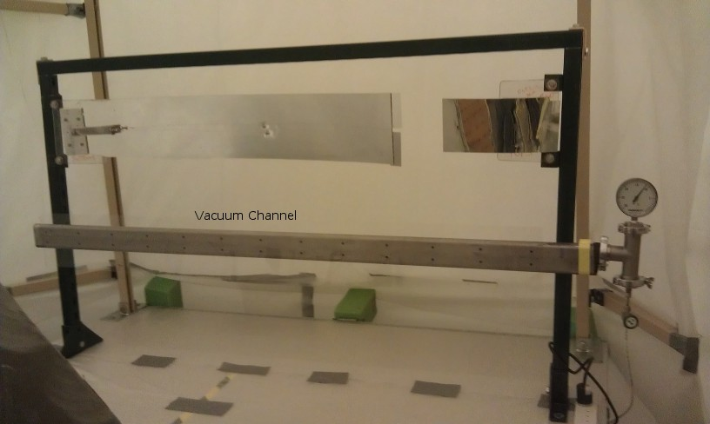

**A mirror and film holding fixture that was designed and built that will allow us to apply the adhesive horizontally (Face out) to allow for a finer mist which will give us the proper bond and minimize the impact of spraying an adhesive within a clean room by utilizing the positive pressure environment to vent any excess gases outside the clean room.**

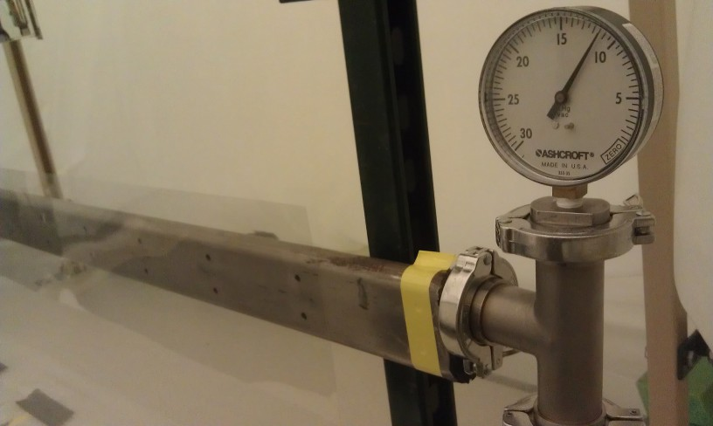

**The vacuum channel designed to hold the coated film horizontally incorporates a gauge and valve that keeps the pressure low enough to hold the material but not so high as to deform it.**

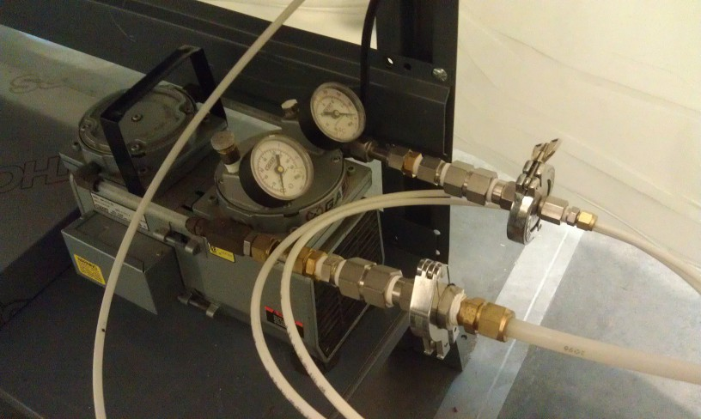

**A Gast dual diaphragm vacuum pump used for the vacuum channel.**

**For the actual application process of applying the Aluminum coated Lexan, a bracket support system was built to hold the mirror firmly while the new film is being applied on top of the exsisting mirror surface. Once the mirror has been recoated it will cure for several days, then the excess material will be trimed away and the mirror will be rebagged and shelved until we are ready to install the mirrors in each unit.**

**A great deal of thought had to be given to keeping this process as fluid as possible. Due to the enormous amount of mirrors to be done, things to consider are, limitations of space, curing times and many other factors, we believe these solutions should help us pave our path to success.**

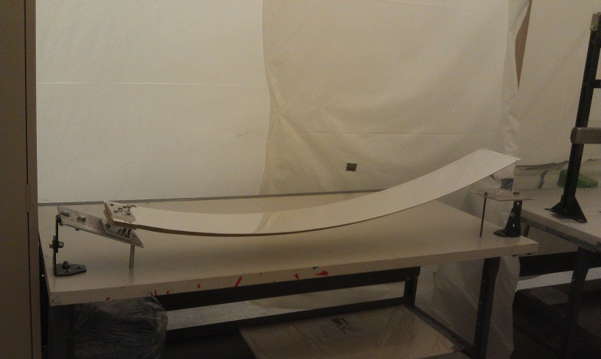

**The mirror support brackets which are used for applying the new mirror surface**

**This overview has been prepared in a general fashion in order to give the reader a better understanding of the current state of the LTCC project.**

**LTCC Project: November 1, 2013**

**Prepared by, David Anderson**